**UNIT-III**

**Solar Photo Voltaic modules**

Solar PV modules from solar cells – series and parallel connection of cells – mismatch in series and parallel connection. Design and structure of PV modules: number of solar cells in a module – wattage of modules – fabrication of PV modules. PV module power output- I-V equation of P.V modules – ratings of P.V modules- I-V and Power curves of module. DC – DC convertors used in Solar systems – maximum power point tracking algorithms.

**32.1 Solar PV modules from solar cells**

A PV module consists of individual solar cells electrically connected together to increase their power output. They are packaged so that they are protected from the environment and so that the user is protected from electrical shock. However, several aspects of PV module design which may reduce either the power output of the module or its lifetime need to be identified. The following chapter will examine how solar cells are encapsulated into PV modules and examines some of the issues which arise as a result of interconnection and encapsulation. The most important effects in PV modules or arrays are:

1. losses due to the interconnection of mismatched solar cells;
2. the temperature of the module; and
3. failure modes of PV modules.

**32.2 series and parallel connection of cells**

A bulk silicon PV module consists of multiple individual solar cells connected, nearly always in series, to increase the power and voltage above that from a single solar cell. The voltage of a PV module is usually chosen to be compatible with a 12V battery. An individual silicon solar cell has a voltage at the maximum power point around 0.5V under 25 °C and AM1.5 illumination. Taking into account an expected reduction in PV module voltage due to temperature and the fact that a battery may require voltages of 15V or more to charge, most modules contain 36 solar cells in series. This gives an open-circuit voltage of about 21V under standard test conditions, and an operating voltage at maximum power and operating temperature of about 17 or 18V. The remaining excess voltage is included to account for voltage drops caused by other elements of the PV system, including operation away from maximum power point and reductions in light intensity.

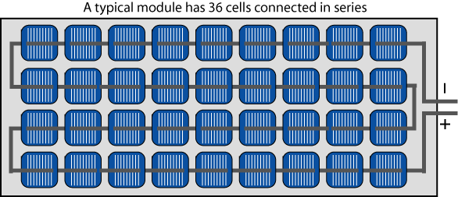

*In a typical module, 36 cells are connected in series to produce a voltage sufficient to charge a 12V battery.*

The voltage from the PV module is determined by the number of solar cells and the current from the module depends primarily on the size of the solar cells. At AM1.5 and under optimum tilt conditions, the current density from a commercial solar cell is approximately between 30 mA/cm2 to 36 mA/cm2. Single crystal solar cells are often 15.6 × 15.6 cm2, giving a total current of almost 9 – 10A from a module.

The table below shows the output of typical modules at STC. IMP and ISC do not change that much but VMP and VOC scale with the number of cells in the module.

| **Cells** | **PMAX** | **VMPP** | **IMPP** | **VOC** | **ISC** | **Efficiency** |
| --- | --- | --- | --- | --- | --- | --- |
| 72 | 340 Wp | 37.9 V | 8.97 A | 47.3 V | 9.35 A | 17.5% |
| 60 | 280 Wp | 31.4 V | 8.91 A | 39.3 V | 9.38 A | 17.1% |
| 36 | 170 Wp | 19.2 V | 8.85 A | 23.4 V | 9.35 A | 17% |

If all the solar cells in a module have identical electrical characteristics, and they all experience the same insolation and temperature, then all the cells will be operating at exactly the same current and voltage. In this case, the IV curve of the PV module has the same shape as that of the individual cells, except that the voltage and current are increased. The equation for the circuit becomes:

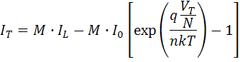

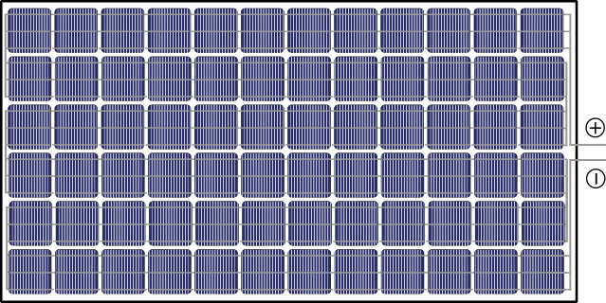  
Modules for residential or large fields usually contain either 60 or 72 cells. There are other sizes such as 96 cell modules but they are much less common.

where:

N is the number of cells in series;

M is the number of cells in parallel;

IT is the total current from the circuit;

VT is the total voltage from the circuit;

I0 is the saturation current from a single solar cell;

IL is the short-circuit current from a single solar cell;

n is the ideality factor of a single solar cell;

and q, k, and T are constants.

The overall IV curve of a set of identical connected solar cells is shown below. The total current is simply the current of an individual cell multiplied by the number of cells in parallel. Such that: ISC total = ISC × M. The total voltage is the voltage of an individual cell multiplied but the number of cells in series. Such that:

ISC(total)=ISC(cell)×M

IMP(total)=IMP(cell)×M

VOC(total)=VOC(cell)×N

VMP(total)=VMP(cell)×N

If the cells are identical then the fill factor does not change when the cells are in parallel or series. However, there is usually mismatch in the cells so the fill factor is lower when the cells are combined. The cell mismatch may come from manufacturing or from differences in light on the cells where one cell has more light than another.

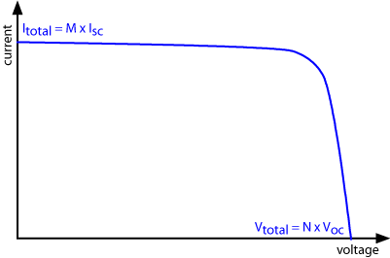

*I-V curve for N cells in series x M cells in parallel.*

**32.3 mismatch in series and parallel connection.**

**Mismatch Effects**

Mismatch losses are caused by the interconnection of solar cells or modules which do not have identical properties or which experience different conditions from one another. Mismatch losses are a serious problem in PV modules and arrays under some conditions because the output of the entire PV module under worst case conditions is determined by the solar cell with the lowest output. For example, when one solar cell is shaded while the remainder in the module are not, the power being generated by the "good" solar cells can be dissipated by the lower performance cell rather than powering the load. This in turn can lead to highly localised power dissipation and the resultant local heating may cause irreversible damage to the module.



*Shading of one region of a module compared to another is a major cause of mismatch in PV modules.*

Mismatch in PV modules occurs when the electrical parameters of one solar cell are significantly altered from those of the remaining devices. The impact and power loss due to mismatch depend on:

* the operating point of the PV module;
* the circuit configuration; and
* the parameter (or parameters) which are different from the remainder of the solar cells.

Differences in any part of the IV curve between one solar cell and another may lead to mismatch losses at some operating point. A non-ideal IV curve and the operating regime of the solar cell is shown below. Although mismatch may occur in any of the cell parameters shown below, large mismatches are most commonly caused by differences in either the short-circuit current or open-circuit voltage. The impact of the mismatch depends on both the circuit configuration and on the type of mismatch, and is demonstrated in more detail in the following pages.

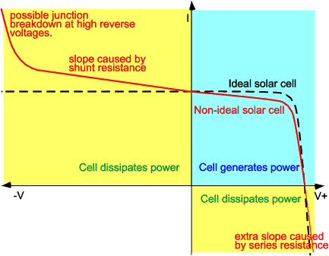

*The comparison of an ideal and a non-ideal solar cell. For mismatch, the greatest difference is when the cell is driven into reverse voltage bias.*

**Mismatch for Cells Connected in series**

As most PV modules are series-connected, series mismatches are the most common type of mismatch encountered. Of the two simplest types of mismatch considered (mismatch in short-circuit current or in open-circuit voltage), a mismatch in the short-circuit current is more common, as it can easily be caused by shading part of the module. This type of mismatch is also the most severe.

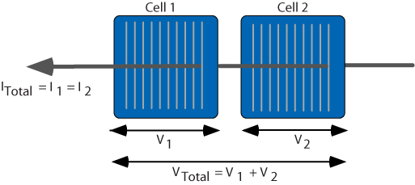

*For two cells connected in series, the current through the two cells is the same. The total voltage produced is the sum of the individual cell voltages. Since the current must be the same, a mismatch in current means that the total current from the configuration is equal to the lowest current.*

**Open Circuit Voltage Mismatch for Cells Connected in Series**

A mismatch in the open-circuit voltage of series-connected cells is a relatively benign form of mismatch. As shown in the animation below, at short-circuit current, the overall current from the PV module is unaffected. At the maximum power point, the overall power is reduced because the poor cell is generating less power. As the two cells are connected in series, the current through the two solar cells is the same, and the overall voltage is found by adding the two voltages at a particular current.

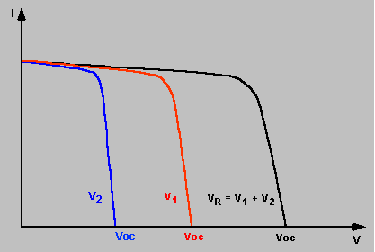

*In the animation, cell 2 has a lower output voltage than cell 1.*

**Short-Circuit Current Mismatch for Cells Connected in Series**

A mismatch in the short-circuit current of series connected solar cells can, depending on the operating point of the module and the degree of mismatch, have a drastic impact on the PV module. As shown in the animation below, at open-circuit voltage, the impact of a reduced short-circuit current is relatively minor. There is a minor change in the open-circuit voltage due to the logarithmic dependence of open-circuit voltage on short-circuit current. However, as the current through the two cells must be the same, the overall current from the combination cannot exceed that of the poor cell. Therefore, the current from the combination cannot exceed the short-circuit current of the poor cell. At low voltages where this condition is likely to occur, the extra current-generating capability of the good cells is not dissipated in each individual cell (as would normally occur at short circuit), but instead is dissipated in the poor cell.

Overall, in a series connected configuration with current mismatch, severe power reductions are experienced if the poor cell produces less current than the maximum power current of the good cells and also if the combination is operated at short circuit or low voltages, the high power dissipation in the poor cell can cause irreversible damage to the module. These effects are illustrated in the two animations below.

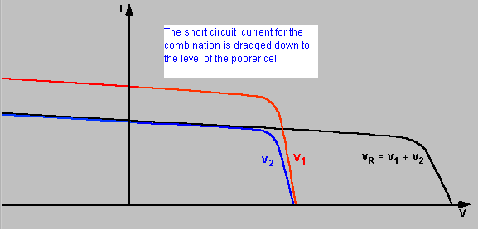

*Current mismatch for two cells in series can be quite serious and quite common. The Isc of the combination is limited to the Isc of the lowest cell.*

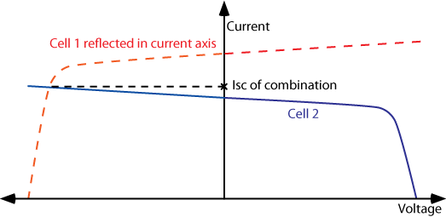

*An easy method of calculating the combined short-circuit current of series connected mismatched cells. The current at the point of intersection represents the short-circuit current of the series combination (ie. V1+V2=0).*

**32.4 Design and structure of PV modules:**

**32.4.1 number of solar cells in a module**

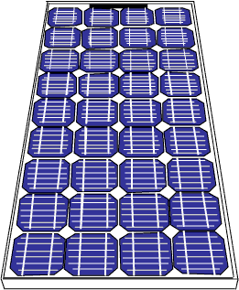

*A typical bulk silicon PV module used in outdoor remote power applications.*

A PV module consists of a number of interconnected solar cells encapsulated into a single, long-lasting, stable unit. The key purpose of encapsulating a set of electrically connected solar cells is to protect them and their interconnecting wires from the typically harsh environment in which they are used. For example, solar cells, since they are relatively thin, are prone to mechanical damage unless protected. In addition, the metal grid on the top surface of the solar cell and the wires interconnecting the individual solar cells may be corroded by water or water vapor. The two key functions of encapsulation are to prevent mechanical damage to the solar cells and to prevent water or water vapor from corroding the electrical contacts.

Many different types of PV modules exist and the module structure is often different for different types of solar cells or for different applications. For example, amorphous silicon solar cells are often encapsulated into a flexible array, while bulk silicon solar cells for remote power applications are usually rigid with glass front surfaces.

The most common modules have either 60 cells or 72 cells with three bypass diodes. 60 cell modules were originally designed for ease of handling in residential applications and heavier 72 cell modules for large utility installations where cranes and hydraulic lift are available. However, it is quite possible to use 72 cell modules in residential installations so long as the rest of the system is designed to handle the large size.

Module lifetimes and warranties on bulk silicon PV modules are over 20 years, indicating the robustness of an encapsulated PV module. A typical warranty will guarantee that the module produces 90% of its rated output for the first 10 years and 80% of its rated output up to 25 years. A third party reinsurance company ensures these warranties are valid in the event the manufacturer goes bankrupt.

**32.6 wattage of modules**

**32.1.2 Module Materials**

Most PV bulk silicon PV modules consist of a transparent top surface, an encapsulant, a rear layer and a frame around the outer edge. In most modules, the top surface is glass, the encapsulant is EVA (ethyl vinyl acetate) and the rear layer is Tedlar, as shown below.

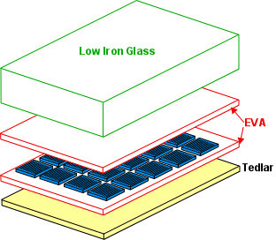

*Typical bulk silicon module materials.*

**Front Surface Materials**

The front surface of a PV module must have a high transmission in the wavelengths which can be used by the solar cells in the PV module. For silicon solar cells, the top surface must have high transmission of light in the wavelength range of 350 nm to 1200 nm. In addition, the reflection from the front surface should be low. While theoretically this reflection could be reduced by applying an anti-reflection coating to the top surface, in practice these coatings are not robust enough to withstand the conditions in which most PV systems are used. An alternative technique to reduce reflection is to "roughen" or texture the surface. However, in this case the dust and dirt is more likely to attach itself to the top surface, and less likely to be dislodged by wind or rain. These modules are not therefore "self-cleaning", and the advantages of reduced reflection are quickly outweighed by losses incurred due to increased top surface soiling.

In addition to its reflection and transmission properties, the top surface material should be impervious to water, should have good impact resistance, should be stable under prolonged UV exposure and should have a low thermal resistivity. Water or water vapor ingress into a PV module will corrode the metal contacts and interconnects, and consequently will dramatically reduce the lifetime of the PV module. In most modules the front surface is used to provide the mechanical strength and rigidity, therefore either the top surface or the rear surface must be mechanically rigid in order to support the solar cells and the wiring.

There are several choices for a top surface material including acrylic, polymers and glass. Tempered, low iron-content glass is most commonly used as it is low cost, strong, stable, highly transparent, impervious to water and gases and has good self-cleaning properties.

**Encapsulant**

An encapsulant is used to provide adhesion between the solar cells, the top surface and the rear surface of the PV module. The encapsulant should be stable at elevated temperatures and high UV exposure. It should also be optically transparent and should have a low thermal resistance. EVA (ethyl vinyl acetate) is the most commonly used encapsulant material. EVA comes in thin sheets which are inserted between the solar cells and the top surface and the rear surface. This sandwich is then heated to 150 °C to polymerize the EVA and bond the module together.

**Rear Surface**

The key characteristics of the rear surface of the PV module are that it must have low thermal resistance and that it must prevent the ingress of water or water vapour. In most modules, a thin polymer sheet, typically Tedlar, is used as the rear surface. Some PV modules, known as bifacial modules are designed to accept light from either the front or the rear of the solar cell. In bifacial modules both the front and the rear must be optically transparent.

**Frame**

A final structural component of the module is the edging or framing of the module. A conventional PV module frame is typically made of aluminium. The frame structure should be free of projections which could result in the lodgement of water, dust or other matter.

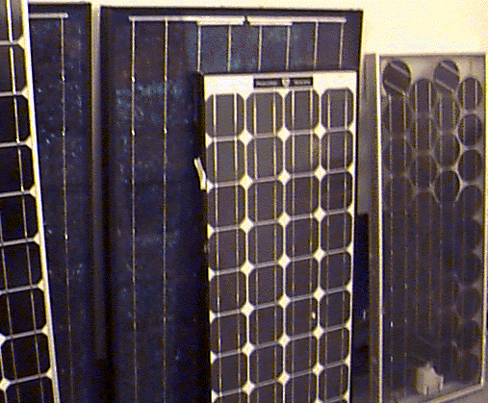

*Several types of silicon PV modules.*

**32.7 fabrication of PV modules.**

32.1.3 **Packing Density**

The packing density of solar cells in a PV module refers to the area of the module that is covered with solar cells compared to that which is blank. The packing density affects the output power of the module as well as its operating temperature. The packing density depends on the shape of the solar cells used. For example, single crystalline solar cells are round or semi-square, while multicrystalline silicon wafers are usually square. Therefore, if single-crystalline solar cells are not cut squarely, the packing density of a single crystalline module will be lower than that of a multicrystalline module. The relative packing density possible with round verses square cells is illustrated below.

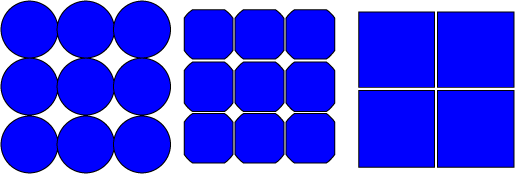

*The packing density of round and square cells. The round ingots of Cz material give a low packing density so the edges are cut off to produce semi-square cells and higher packing density. Multicrystalline material is cast in square blocks, giving a high packing density.*

Sparsely packed cells in a module with a white rear surface can also provide marginal increases in output via the "zero depth concentrator" effect [1](https://www.pveducation.org/pvcdrom/modules-and-arrays/packing-density#footnote1_c0qsgz5), illustrated below. Some of the light striking regions of the module between cells and cell contacts is scattered and channelled to active regions of the module.

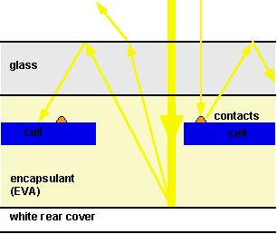

*The "zero-depth concentration effect" in modules with sparsely packed cells and a white rear surface.*

**32.8 PV module power output-**

The power rating tells you how much power a solar panel was designed to produce. It measures the wattage of a panel when it is operating at standard test conditions.

“Standard test conditions” is when there is a cell temperature of 77F° (25C°), and 1 kilowatt per square meter of solar energy shining on the panel.

In other words, a solar panel’s power rating measures how much electricity an individual solar panel will produce under ideal operating conditions.

The amount of electricity produced by a solar panel can vary based on three factors:

1. Efficiency of the solar cells
2. Number of solar cells it contains
3. Type of solar panel

**32.9 I-V equation of P.V modules –**

The main points of the *I-V* and *P-V* curves characteristics are the short-circuit current (Isc) or the maximum current at zero voltage, and the open-circuit voltage (Voc) or the maximum voltage at zero current. For each point in the *I-V* curve, the product of the current and voltage represents the output power for that operating condition. The MPP produced by the PV generator is reached at a point on the characteristic where the product *I-V* is maximum (Pm). The fill factor (FF) is defined as the ratio between Pm and the product Isc*·*Voc, which shows curve squareness. Hence, Pm = Isc.Voc.FF the closer to the unit the fill factor is, the better cell quality will be. Typical characteristic curves of a PV module are plotted in Figure, with irradiance and temperature as parameters.

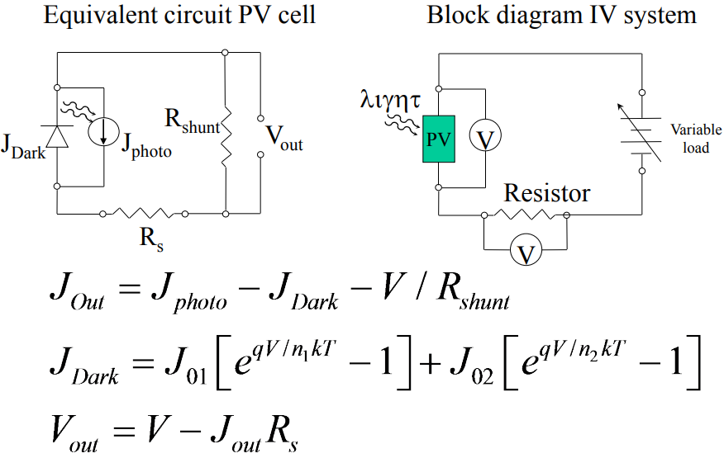

**32.10 ratings of P.V modules-**

When comparing [solar panels](https://www.solaris-shop.com/solar-panels/), it is important to consider output wattages, total capacity and power output. The production output of solar panels varies depending on a number of factors, such as where you live (number of sun hours), ambient temperature and efficiency ratings. Here is our breakdown of what to look for, and how to compare solar modules.

Solar panel watts represent the panel’s expected power production under ideal sunlight and temperature conditions. Typical modules are rated between 250 to 400 watts, with higher watt modules being the preferred options. Higher watt modules not only usually have higher efficiency ratings but require less modules to achieve your ideal energy needs. The overall wattage of your system is what primarily determines the cost of your system.

Wattage is calculated by multiplying the total volts and amps of the solar module. Module volts represent the force of the electricity generated by the panels, while amps refer to the aggregate amount of energy used. All technical data can regarding your chosen module can be found in the specifications sheet provided by the manufacturer.

**32.11 I-V and Power curves of module.**

The main points of the *I-V* and *P-V* curves characteristics are the short-circuit current (Isc) or the maximum current at zero voltage, and the open-circuit voltage (Voc) or the maximum voltage at zero current. For each point in the *I-V* curve, the product of the current and voltage represents the output power for that operating condition. The MPP produced by the PV generator is reached at a point on the characteristic where the product *I-V* is maximum (Pm). The fill factor (FF) is defined as the ratio between Pm and the product Isc*·*Voc, which shows curve squareness. Hence, Pm = Isc.Voc.FF the closer to the unit the fill factor is, the better cell quality will be. Typical characteristic curves of a PV module are plotted in Figure, with irradiance and temperature as parameters.

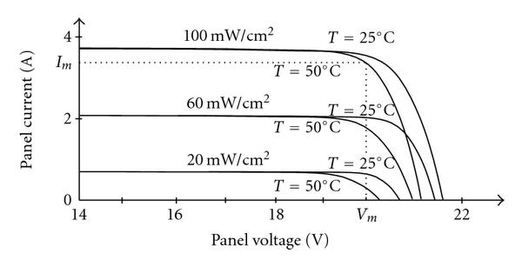

**32.12 DC – DC convertors used in Solar systems**

There are three basic types of dc-dc converter circuits, termed as buck, boost and buck-boost. In all of these circuits, a power device is used as a switch. This device earlier used was a thyristor, which is turned on by a pulse fed at its gate. In all these circuits, the thyristor is connected in series with load to a dc supply, or a positive (forward) voltage is applied between anode and cathode terminals. The thyristor turns off, when the current decreases below the holding current, or a reverse (negative) voltage is applied between anode and cathode terminals. So, a thyristor is to be force-commutated, for which additional circuit is to be used, where another thyristor is often used. Later, GTO’s came into the market, which can also be turned off by a negative current fed at its gate, unlike thyristors, requiring proper control circuit. The turn-on and turn-off times of GTOs are lower than those of thyristors. So, the frequency used in GTO-based choppers can be increased, thus reducing the size of filters. Earlier, dc-dc converters were called ‘choppers’, where thyristors or GTOs are used. It may be noted here that buck converter (dc-dc) is called as ‘step-down chopper’, whereas boost converter (dc-dc) is a ‘step-up chopper’. In the case of chopper, no buck-boost type was used.

With the advent of bipolar junction transistor (BJT), which is termed as self-commutated device, it is used as a switch, instead of thyristor, in dc-dc converters. This device (NPN transistor) is switched on by a positive current through the base and emitter, and then switched off by withdrawing the above signal. The collector is connected to a positive voltage. Now-a-days, MOSFETs are used as a switching device in low voltage and high current applications. It may be noted that, as the turn-on and turn-off time of MOSFETs are lower as compared to other switching devices, the frequency used for the dc-dc converters using it (MOSFET) is high, thus, reducing the size of filters as stated earlier. These converters are now being used for applications, one of the most important being Switched Mode Power Supply (SMPS). Similarly, when application requires high voltage, Insulated Gate Bi-polar Transistors (IGBT) are preferred over BJTs, as the turn-on and turn-off times of IGBTs are lower than those of power transistors (BJT), thus the frequency can be increased in the converters using them. So, mostly self-commutated devices of transistor family as described are being increasingly used in dc-dc converters.

**Buck Converters (dc-dc)**

A buck converter (dc-dc) is shown in Fig. 17.1a. Only a switch is shown, for which a device as described earlier belonging to transistor family is used. Also a diode (termed as free wheeling) is used to allow the load current to flow through it, when the switch (i.e., a device) is turned off. The load is inductive (R-L) one. In some cases, a battery (or back emf) is connected in series with the load (inductive). Due to the load inductance, the load current must be allowed a path, which is provided by the diode; otherwise, i.e., in the absence of the above diode, the high induced emf of the inductance, as the load current tends to decrease, may cause damage to the switching device. If the switching device used is a thyristor, this circuit is called as a step-down chopper, as the output voltage is normally lower than the input voltage. Similarly, this dc-dc converter is termed as buck one, due to reason given later.

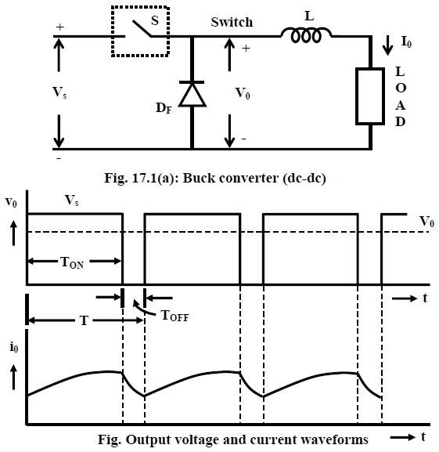

The output voltage and current waveforms of the circuit (Fig. 17.1a) are shown in Fig. 17.1b. The output voltage is same as the input voltage, i.e., *v*=0, when the switch is ON, during the period, *TON* ≥ *t* ≥ 0 . The switch is turned on at *t* = 0, and then turned off at t = TON. This is called ON period. During the next time interval, T ≥ t ≥ TON, the output voltage is zero, i.e., *vo = 0* , as the diode, DF now conducts. The OFF period is TOFF = T – TON, with the time period being T = TON + TOFF. The frequency is f = 1/T. With T kept as constant, the average value of the output voltage is,

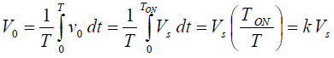

The duty ratio is k = (TON/T) = [TON/(TON + TOFF), its range being 1.0 ≥ K ≥ 0.0. Normally, due to turn-on delay of the device used, the duty ratio (k) is not zero, but has some positive value. Similarly, due to requirement of turn-off time of the device, the duty ratio (k) is less than 1.0. So, the range of duty ratio is reduced. It may be noted that the output voltage is lower than the input voltage. Also, the average output voltage increases, as the duty ratio is increased. So, a variable dc output voltage is obtained from a constant dc input voltage. The load current is assumed to be continuous as shown in Fig. 17.1b. The load current increases in the ON period, as the input voltage appears across the load, and it (load current) decreases in the OFF period, as it flows in the diode, but is positive at the end of the time period, T.

**Boost Converters (dc-dc)**

A boost converter (dc-dc) is shown in Fig. 17.2a. Only a switch is shown, for which a device belonging to transistor family is generally used. Also, a diode is used in series with the load. The load is of the same type as given earlier. The inductance of the load is small. An inductance, L is assumed in series with the input supply. The position of the switch and diode in this circuit may be noted, as compared to their position in the buck converter.

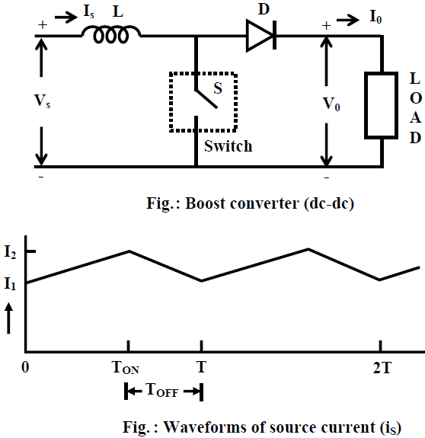

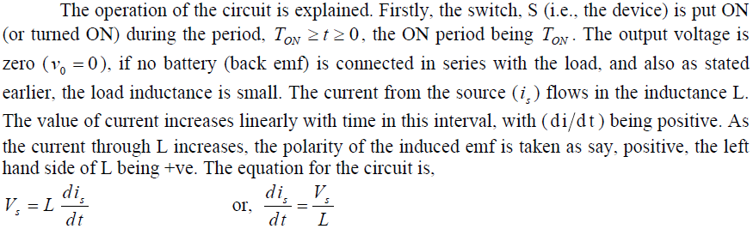

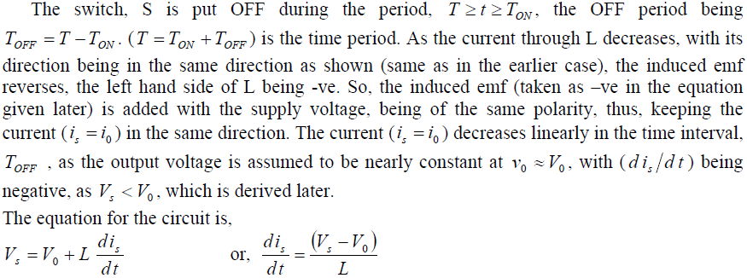

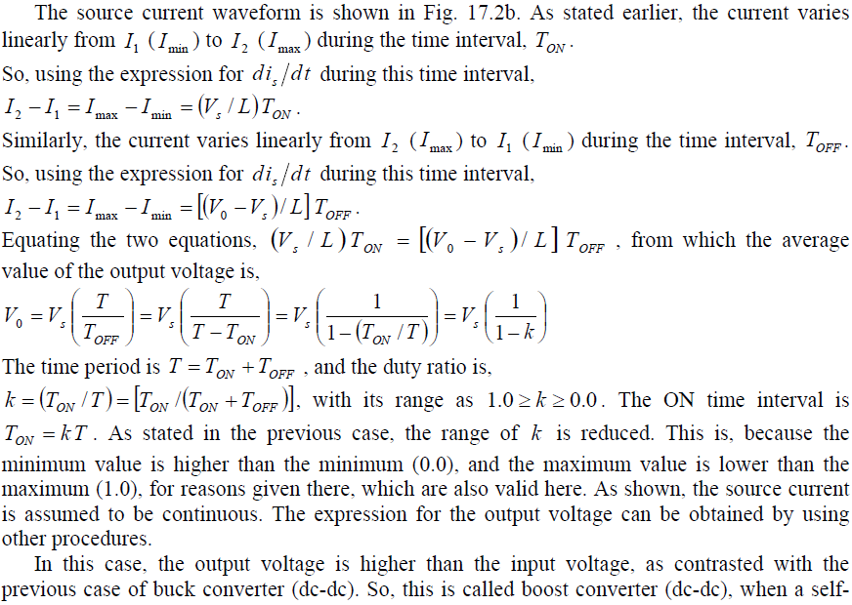



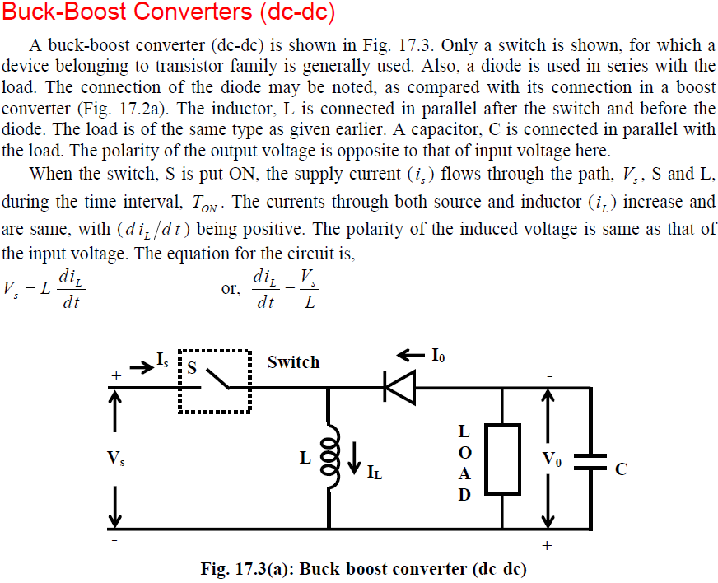

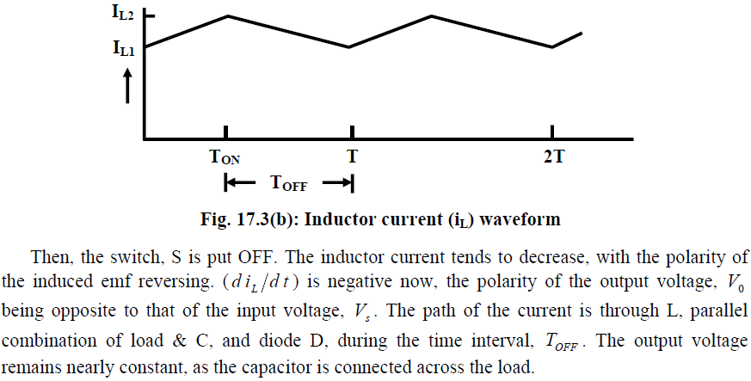

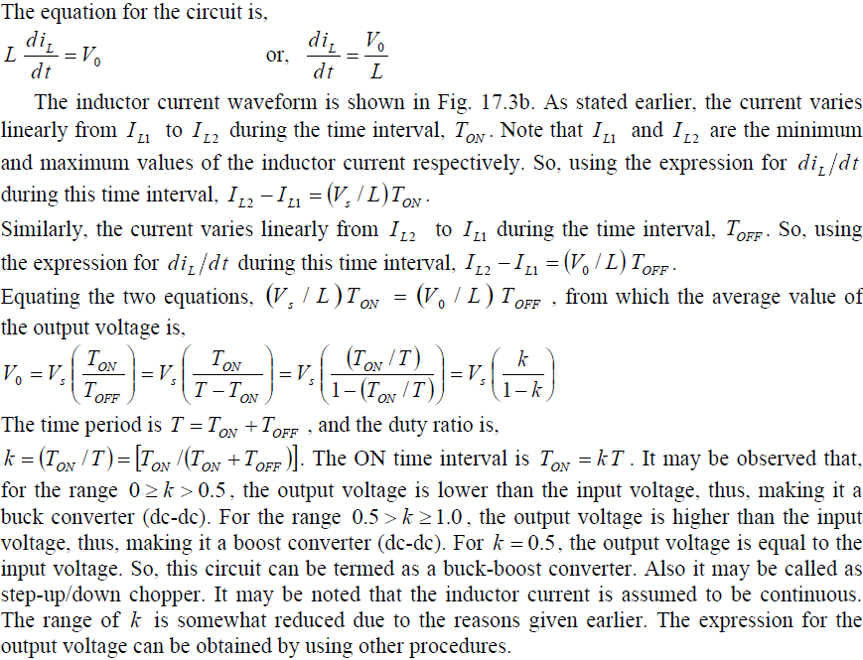

**32.13 maximum power point tracking algorithms.**

The equation for the IV curve in the first quadrant is:



The -1 term in the above equation can usually be neglected. The exponential term is usually >> 1 except for voltages below 100 mV. Further, at low voltages, the light generated current ILdominates the I0(...) term so the -1 term is not needed under illumination.



Plotting the above equation gives the IV curve below with the relevant points on the curve labeled and discussed in more detail on the following pages. The power curve has a a maximum denoted as PMP where the solar cell should be operated to give the maximum power output. It is also denoted as PMAX or maximum power point (MPP) and occurs at a voltage of VMP and a current of IMP.

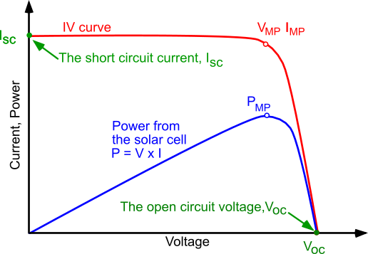

*Current voltage (IV) cure of a solar cell. To get the maximum power output of a solar cell it needs to operate at the maximum power point, PMP.*